

A Word from Fr Jim
Lent has begun and even if you are late starting, don’t be worried,
you can start now, today.

Last week, I mentioned the idea of having a daily spiritual practice.
Here are some ideas.

1. Read the Gospel of Mark during lent. A great way to begin is to come along on Monday night @ 7pm and hear Stefan Smart reciting it in one session.
It will be a good kick start.

2. Read a good book. If you have John O’ Donoghue
“Divine Beauty” read a little each day.

3. Join us for Morning and Evening prayer in the Icon Chapel
(Sundays, Mondays, Wednesdays, and Fridays 9:15am)
Tuesdays, Thursdays, Saturdays @10:am
Mondays, Tuesdays, Wednesdays & Thursday evenings @7:pm
or find time to pray in silence every day.

With My Love & Blessing
Fr Jim

The Praying Monk
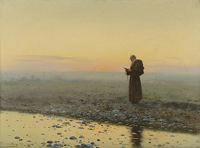

The Spanish painting I am sharing with you today, by J. Ferrer y Pallej, from 1899,
is not well known, but one I have always liked. It depicts a monk at prayer on a pebbled beach at dawn… engaging with God… it is highly likely that during his prayers he will have recited the Lord's Prayer. The light in this painting together with the sense of solitude are magnificent.
The artist was a Spanish painter who specialised in landscapes and portraits, made with oils and pastels. The mastering of the skies is one of his unique features.
By Father Patrick van der Vo

