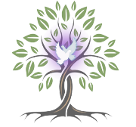

A Word from Fr Jim

It’s hard to believe that we have reached Halloween and the shops are full of
Christmas cheer!! Here are some upcoming events in the parish.

· Friday November 1st All Saints Day, 10am Mass.

· Saturday November 2nd All Souls Day 6pm Mass

· Sunday November 3rd “I am Mark”. 7pm Gospel of Mark performed by Stefan Smart.

· Tuesday 5th November, Evening Prayer for the dead.

7pm: Wedgewood, Moreen, Blackthorn, Balally, Sandyford Road

7.45pm: Clonard, Parkvale, Dun Emer, Ballawley, Delbrook, College area & Wesley

8.30pm Service of light for all who have died in the last year

With My Love & Blessing
Fr Jim

